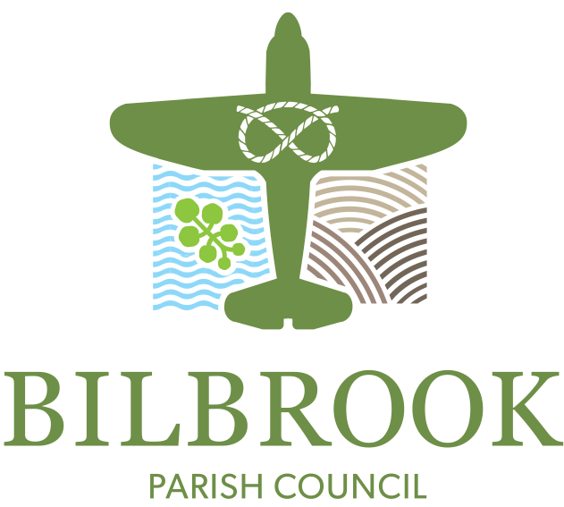
Bilbrook Parish Council
Bilbrook Village Hall
Joeys Lane
Bilbrook
South Staffordshire
WV8 1JL
Tel: 01902 840007
Email: clerk@bilbrookparishcouncil.gov.uk
www.bilbrookparishcouncil.gov.uk
Office Opening hours: 10:00 am – 12:00 noon weekdays except Thursday

Bilbrook at Christmas Event
Friday 26th November 2021, 6:00 - 8:00 pm (Trading Time)
Bilbrook Village Green
STALLS BOOKING REQUEST FORM

Contact Name: ………………………………………………………………
Business/Trading
Name (if applicable) ……………………………………………………………….

Mobile Phone: …………………………………… Email: …………………………………………………………………

Space required (m x m): ……………………………………………

Please describe briefly what goods/services your stall will sell/offer:

……………………………………………………………………………………………………………………………………………….
Please note:
- N.B. If you are selling food, we need to see a copy of your food hygiene certificate renewed in the last 3 years.
- Your stall must be self-sufficient in equipment; we cannot offer any furniture or guarantee electricity supply.
- Traders must be covered by Public Liability Insurance. Please send a copy of your Public Liability insurance certificate with this form.
- There is no charge for stalls but we ask that stalls that are not organised by community groups give a contribution to the chosen charity for the event.
- If you are planning to use a mobile generator please provide us with the details.

Once we have received your request for a stall, we will contact you to confirm whether you have been offered a place.
I have read and agree to abide by the terms and conditions and read the privacy statement below.

Signed ………………………………………………… Date ……………………………….

Please return the completed form to the clerk@bilbrookparishcouncil.gov.uk

Data Protection – What you need to know.
Data Controller - We Bilbrook Parish Council are a ‘controller’ of your personal data (“your information”). Our address is Bilbrook Village Hall, Joey’s Lane, Bilbrook WV8 1JL. Our telephone number is 01902 840007.
Purpose and Lawful Basis of Processing - We process your information to enable us to progress applications for stalls. We do so in the public interest.
Who We May Share Information with - We will share your information with Parish Councillors to decide whether a stall can be offered.
Retention - We will retain this form for two years after the event.
Your rights - You have the right to request access to your information; to have incorrect information rectified; to have your information erased and to have our use of your information restricted.
Complaints - If you are unhappy about the way we have processed your information please speak to the Clerk to the Parish Council in the first instance. However, notwithstanding this, you do have the right to complain to the Information Commissioner.

